**TULUM / CENOTE CASA TORTUGA**

**PRIVATE EXCURSION**

**October 4, 2024**

**TULUM ARCHAEOLOGICAL SITE**

The Mayan city of Tulum stands 130 km south and 700 years away of Cancun. But the contrast between the two, can be measured in more than just distance and time. Cancun is a string of large resort hotels, which did not exist prior to 1974 and which specialize in the expected. Tulum, on the other hand, was built late in the thirteenth century, during what is known as the Mayan post-classic period. With a little imagination and knowledge, the ruins become a giant puzzle waiting to be pieced together.

The city of Tulum was previously known as Zama, meaning City of Dawn. Its current name means “fence or trench” in Mayan. It is a rare city built by the Mayans because it is one of the few walled cities. Being both on a sea and land route, it had major historical importance as a center of trading. The city flourished between the 13th and the 15th centuries, fading only 70 years after the Spanish army started conquering today’s Mexico. Although there is no specific data about its population at its height, estimates put it between 1,000 and 1,600. The site was inhabited as early as the 6th century.

Tulum ruins are perched on 12 meters high cliffs facing the Caribbean Sea. It is the 3rd most visited site in Mexico and the most visited spot in the state of Quintana Roo.

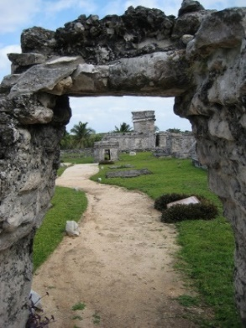 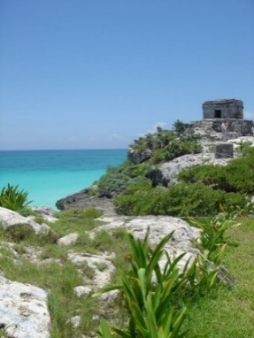

**CASA TORTUGA CENOTE**

Casa Tortuga might just be one of the best off-the-path cenotes in Tulum. It is newly opened so not too many people actually know how awesome this place is… Yet.

Visiting Casa Tortuga is sort like a cenote tour of a series of three cenotes in a park. A tour guide leads you to visit two cave cenotes and an open cenote. One of the cave cenotes you are led inside where you can see bats and interesting blind cave fish. In the other, you are taught about the rock formations and interesting cave geology facts while experiencing slight vertigo caused by the crystal-clear water and the sheer depth of the cave. The open cenote is mainly for fun. You can jump in off the edge and swim around. If you’re lucky you’ll spot a resident turtle swimming alongside you.

The cenotes of Casa Tortuga are perfect for newbies who want an in-depth introduction into the cenotes on a tour. The cenote tour can take some time, especially if you need to wait for more members before the tour can leave, so make sure you leave at least a few hours to complete the entire route.

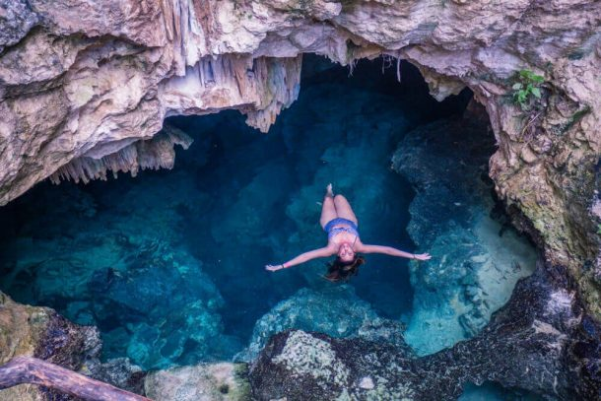 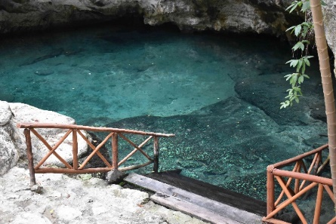

FACILITIES AT CENOTE: There is a shower, toilet and restaurant on site.

Life jackets and snorkel are included in the price

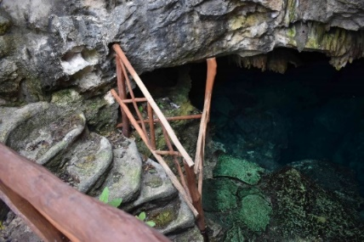

**Tulum & Cenote Casa Tortuga**

**Suggested itinerary: 6.45 a.m. to 2.45 p.m.**

Itinerary:

6:45 a.m. Meet at the Hotel Lobby

7:00 a.m. Departure to Tulum

8.00 a.m. Arrival to Tulum

8.00 / 9.30 a.m. Guided explanation of the Site and free time

9.45 a.m. Departure to the Cenote

10:45 a.m. Arrival to Casa Tortuga Cenote

10:45 / 12.30 p.m. Guided tour at the Cenote

12.30 / 1.30 p.m. Lunch at Cenote

1.45 p.m. Departure to Hotel

2.45 p.m. Estimated arrival time at the Hotel

Recommended:

Bring towels from the hotel, bring sun hat and comfortable clothing (wet shoes, shorts, t-shirt and extra clothing if getting wet), Sun glasses, repellent and biodegradable suntan lotion

Included:

Private transportation for the event, YCDMC Staff all the time, entrances at Tulum, Official English Guide at Tulum, entrances at the Cenote, live jackets at the Cenote, Guide from the cenote for the tour and explanation, Regional buffet: Lime soup or charro beans, salad, chicken pibil, pork pibil, Pasta, Rice, Beens. Drinks at cenote NOT INCLUDED. On board the van: bottled water, soft drinks, 2 beers per person, taxes included

**COST OF THE TOUR PER PERSON - $100 US Dlls. / Adult or Children**

**We are considering a guarantee of 30 ppl as a minimum**

**Gratuities – Suggested $10 US Dlls. Per person**

**CONFIRMATION PROCEDURES**

1.- Confirmation on your participation should be received no later than **September 29, 2024**

2.- Once we have the total guests for the tour, the link for the payment will be sent and all payments should be received no later than October 1st. If payment is not received, we will consider that you were not interested and your space will be released.

3.- **Guarantee for a private event: 30 participants**

**CANCELLATION POLICIES**

As this is a private tour the following cancellations will apply:

1.- 50% of the total tour will be reimbursed if cancellation is 72 hrs prior the day of the evet

2.- 25% of the total tour will be reimbursed if cancellation is 48 hrs prior the day of the event

3.- NO REIMBURSES will apply if cancellation is received 24 hrs prior the day of the tour or same day of the event

Any questions, please let me know

Alejandra Orozco

Sales Director

[Alex.orozco@yourcancundmc.com](mailto:Alex.orozco@yourcancundmc.com)